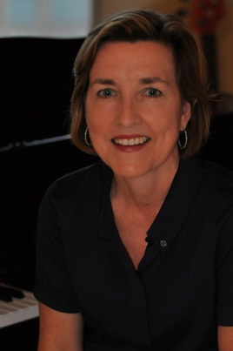
JEAN CHEEVER
cheever100@gmail.com
609-213-5340

Experience/Expertise

Entertainment
Produced the multi award-winning hit Off Broadway musical comedy The Toxic Avenger. Past theatrical credits include Broadway's Dirty Rotten Scoundrels (Tony nominated for Best Musical) and All Shook Up. Co-author of Mambo Italiano, a musical comedy in development. Co-inventor on patents for two music and entertainment apps. Founding member and current Chair of the Director’s Council for The University of Texas at Austin Department of Theatre and Dance.
Biotech/Pharmaceutical
- StemBioSys
Board Member of this early-stage stem cell and regenerative medicine biotech founded in San Antonio. Audit and Governance Committee Chair. Actively participated in fundraising for the $8 million Series A round.
- Other Biotech/Health
Currently serves as a mentor/strategic advisor for several local biotech start-ups developing solutions to unmet needs including cancer vaccines and non-addictive pain medication. Member of the Board of Governors of the Cancer Therapy & Research Center (CTRC) and the San Antonio Mayor’s Fitness Council.
- Bristol-Myers Squibb
Former executive of this $16 billion global biopharmaceutical based in New York City. Started as a senior internal auditor in the company’s New York office and progressed through various diverse roles including the financial integration of the merger of Bristol-Myers with Squibb Company, creating what was then the world's second-largest pharmaceutical enterprise, and served as project lead for multi-functional, global indirect spending initiatives netting millions in cost savings.

Banking/Finance/Accounting
- Broadway Bank
Board Member of this $3 billion privately-held community bank with 40 locations in San Antonio, Austin and surrounding areas. Currently serve on Directors Loan Committee and Directors Asset Liability Committee; formerly Directors Audit Committee.
- Alamo Iron Works
Former Assistant Controller of this privately-held 140 year old San Antonio industrial distributor of supplies, steel, fabrication and rebar products.
- EY (Ernst & Young)
Former Senior Auditor in the San Antonio office of this multinational "Big Four" audit firm.

Education
- MBA - University of Texas at Austin
- BBA - Southern Methodist University
- Certified Public Accountant
- Certified Purchasing Manager
- Currently enrolled in Codeup (16 week full-time boot camp for computer programming focusing on LAMP stack including Linux, Apache, MySQL, and PHP)

